Assignment-4 Python Programming

|  |  |  |
| --- | --- | --- |
|  | Date | 11 October2022 |
| Team ID | PNT2022TMID08105 |
| Project Name | Project – Traffic and Capacity Analytics for Major Ports. |

In [1]:

import

pandas

as

pd

import

numpy

as

np

import

matplotlib

.

pyplot

as

plt

import

seaborn

as

sns

# Loading the dataset

In [ ]:

df

=

pd

.

read_csv

(

'Mall_Customers.csv'

)

df

Out[]: CustomerID Gender Age Annual Income (k$) SpendingScore (1-100)

1. 1 Male 19 15 39
2. 2 Male 21 15 81
3. 3 Female 20 16 6
4. 4 Female 23 16 77
5. 5 Female 31 17 40

... ... ... ... ... ...

1. 196 Female 35 120 79
2. 197 Female 45 126 28
3. 198 Male 32 126 74
4. 199 Male 32 137 18 199 200 Male 30 137 83

200 rows × 5 columns

# Encoding CategoricalColumns

|  |  |  |
| --- | --- | --- |
| from s klearn.prepr ocessing impor t LabelE ncoder LabelE ncoder()  df['Gen der'] = le.fit_ transform(df['Gen der']) | le | = |
| df |  |  |

In [ ]:

In [ ]:

Out[]:

Cu stomerID Gender Age Annual In come (k$) SpendingScore (1-100)

1. 1 1 19 15 39
2. 2 1 21 15 81
3. 3 0 20 16 6
4. 4 0 23 16 77
5. 5 0 31 17 40

... ... ... ... ... ...

* 1. 196 0 35 120 79
  2. 197 0 45 126 28
  3. 198 1 32 126 74
  4. 199 1 32 137 18
  5. 200 1 30 137 83
  6. rows × 5 columns

Visualizations

# UnivariateAnalysis

|  |
| --- |
| plt.hist(df['Age']) |

In [ ]:

(array([31., 19., 34., 29., 16., 26., 15., 10., 6., 14.]), Out[ ]:

array([18. , 23.2, 28.4, 33.6, 38.8, 44. , 49.2, 54.4, 59.6, 64.8, 70. ]), <a list of 10 Patch objects>)

In [ ]:

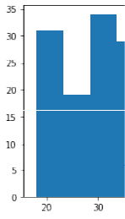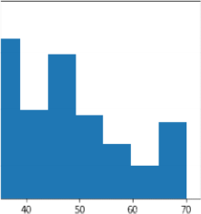

(array([24.,

22., 28.,38., 30., 36., 8., 6., 4.,

4.]),Out[]: array([ 15. , 27.2,

39.4,

|  |
| --- |
| plt.hist(df['AnnualIncome (k$)']) |

51.6, 63.8, 76.

, 88.2,

100.4,

112.6,124.8,137. ]),

<a list of 10 Patch objects>)

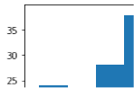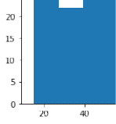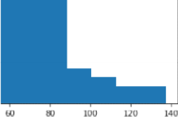

|  |
| --- |
| plt.hist(df['Spending Score (1-100)']) |

In [ ]:

Out[ ]: (array([16., 20., 10., 17., 35., 37., 11., 24., 14., 16.]), array([ 1. , 10.8,20.6,30.4,40.2,50. , 59.8,69.6,79.4,

89.2,99. ]),

<a list of 10 Patch objects>)

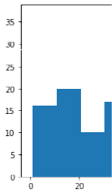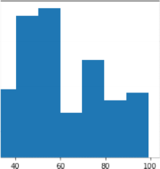

In [ ]:

sns.countplot(df['Gender'])

/usr/local/lib/python3.7/dist-packages/seaborn/_decorators.py:43: FutureWarnin g: Pass the following variable as a keyword arg: x. From version 0.12, the only valid positional argument will be `data`, and passing other arguments without a n explicit keyword will result in an error or misinterpretation.

FutureWarning

<matplotlib.axes._subplots.AxesSubplot at 0x7fdb93a2d490> Out[]:

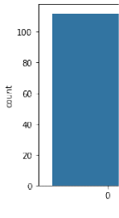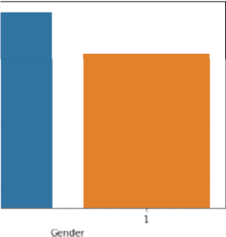

# Bi-VariateAnalysis

In [ ]:

sns.scatterplot(df['Annual Income (k$)'], df['Spending Score (1-100)'])

/usr/local/lib/python3.7/dist-packages/seaborn/_decorators.py:43: FutureWarnin g: Pass the following variables as keyword args: x, y. From version 0.12, the o nly valid positional argument will be `data`, and passing other arguments witho ut an explicit keyword will result in an error or misinterpretation. FutureWarning

<

matplotlib.axes._subplots.AxesSubplot

at 0x7fdb93a1f1d0>

Out[

]:

I

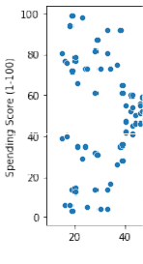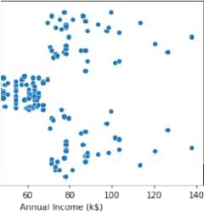

n

[ ] :

sns.barplot(df['Gender'], df['Age'])

/usr/local/lib/python3.7/dist-packages/seaborn/_decorators.py:43: FutureWarnin g: Pass the following variables as keyword args: x, y. From version 0.12, the o nly valid positional argument will be `data`, and passing other arguments witho ut an explicit keyword will result in an error or misinterpretation.

FutureWarning

<matplotlib.axes._subplots.AxesSubplot at 0x7fdb93931b90> Out[]:

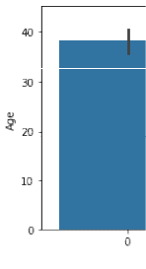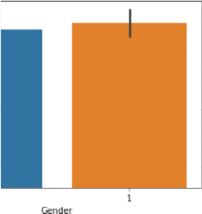

In [ ]: sns.heatmap(df.corr(), annot = True)

<matplotlib.axes._subplots.AxesSubplot at 0x7fdb9390e4d0> Out[ ]:

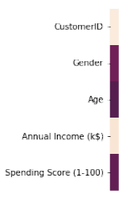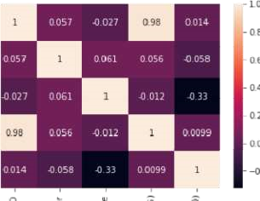

Multi

-

variate

Analysis

In

[

]:

<

seaborn.axisgrid.PairGrid

at 0x7fdb91011e50>

Out[

]:

Descriptive

Statistics

In

[

]:

<

class

'pandas.core.frame.DataFrame'>

RangeIndex:

200

entries,

0

to

199

Data

columns

total

(

5

columns):

#

Column

Non

-

Null

Count

Dtype

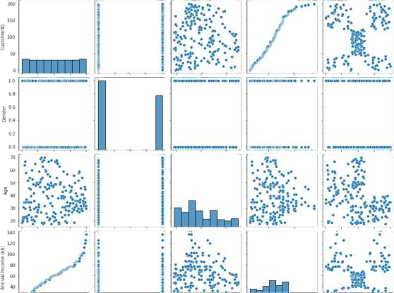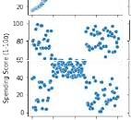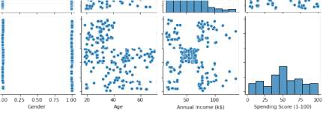

sns

.

pairplot

(

df

)

df

.

info

()



1. CustomerID 200 non-null int64
2. Gender 200 non-null int64 2 Age 200 non-null

int64

1. Annual Income (k$) 200 non-null int64 4 Spending Score

(1-100) 200 non-null int64 dtypes: int64(5) memory usage: 7.9 KB

In [ ]: df.describe()

Out[]: CustomerID Gender Age Annual Income (k$)SpendingScore (1-100)

df.skew()

|  |  |  |  |  |  |  |  |
| --- | --- | --- | --- | --- | --- | --- | --- |
| In [ ]: | mean  min | count  std  25%  50%  75% max | 200.000000 200.000000 200.000000 | | | 200.000000  60.560000  26.264721  15.000000  41.500000  61.500000  78.000000 137.000000 | 200.000000  50.200000  25.823522  1.000000  34.750000  50.000000  73.000000  99.000000 |
| 100.500000  57.879185  1.000000  50.750000 100.500000 150.250000  200.000000 | 0.440000  0.497633  0.000000  0.000000  0.000000  1.000000  1.000000 | 38.850000  13.969007  18.000000  28.750000  36.000000  49.000000  70.000000 |
| Out[]: CustomerID  Gender  Age | |  |  | 0.000000 0.243578  0.485569 |  |  |  |
| AnnualIncome (k$) | | | | 0.321843 | |

Spending Score (1-100) -0.047220dtype: float64

|  |
| --- |
| df.kurt() |

In [ ]:

Out[ ]: Spending Score (1-100)-0.826629 dtype: float64

|  |  |  |
| --- | --- | --- |
| In [ ]: | df.corr () | -1.200000 |

Gender -1.960375

Age -0.671573

AnnualIncome (k$) -0.098487

Annual Income

Out[]: SpendingScore

CustomerID Gender Age (k$) (1-100)

CustomerID

|  |  |  |  |  |  |
| --- | --- | --- | --- | --- | --- |
| CustomerID  Gender  Age  Annual Income (k$)  SpendingScore (1- 100) | 1.000000  0.057400  -0.026763  0.977548  0.013835 | | 0.057400-0.026763  1.000000 0.060867  0.060867 1.000000  0.056410-0.012398  -0.058109 -0.327227 | 0.977548  0.056410  -0.012398  1.000000  0.009903 | 0.013835  -0.058109 -0.327227  0.009903  1.000000 |
| df.var() | |  | |  |  |
| CustomerID | | 3350.000000 | |  |  |
| Gender | | 0.247638 | |  |  |
| Age | | 195.133166 | |  |  |
| AnnualIncome (k$) | | 689.835578 | |  |  |
| Spending Score (1-100) dtype:  float64 | | 666.854271 | |  |  |
| df.std() | |  | |  |  |
| CustomerID | | 57.879185 | |  |  |
| Gender | | 0.497633 | |  |  |
| Age | | 13.969007 | |  |  |
| AnnualIncome (k$) | | 26.264721 | |  |  |
| Spending Score (1-100) 25.823522 dtype: float64  Checking for missing values | | | |  |  |
| df.isna().sum() | | | | | |

In [ ]:

Out[ ]:

In [ ]:

Out[ ]:

In [ ]:

Out[]:

CustomerID

0

Gender 0 Age 0 Spending Score (1-100)

0

dtype: int64

|  |
| --- |
| df.isna().sum().sum() |

In [ ]:

0 Out[]: In [ ]:

df.duplicated().sum()

0 Out[ ]:

# Finding & Handling Ouliers

|  |  |
| --- | --- |
|  | In [ ]:  quantile= df.quantile(q = [0.25, |
| 0.75]) | quantile |

Out[ ]: CustomerID Gender Age Annual Income (k$)SpendingScore (1-100)

|  |  |  |  |  |  |
| --- | --- | --- | --- | --- | --- |
| 0.25 50.75 | 0.0 28.75 | | | 41.5 | 34.75 |
| 0.75 150.25 | 1.0 49.00 | | | 78.0 | 73.00 |
| IQR = quantile.iloc[1]-  IQR | | quantil |  |  |  |
| CustomerID | | 99.50 |  |  |  |
| Gender | | 1.00 |  |  |  |
| Age | | 20.25 |  |  |  |
| AnnualIncome (k$) | | 36.50 |  |  |  |
| Spending Score (1-100) float64 | | dtype:38.25 |  |  |  |
| upper = quantile.iloc[1]upper | | + (1.5 *IQR) | |  |  |
| CustomerID | | 299.500 | |  |  |
| Gender | | 2.500 | |  |  |
| Age | | 79.375 | |  |  |
| AnnualIncome (k$) | | 132.750 | |  |  |
| Spending Score (1-100) float64 | | dtype:130.375 | |  |  |
| loCwuesrto=mqeurIaDntile.iloc[0] lower | | -9(81..550*0IQR) | |  |  |
| Gender | | -1.500 | |  |  |

In [ ]:

Out[ ]:

In [ ]:

Out[ ]:

In [ ]:

Out[ ]:

Annual Income (k$) -13.250 Spending Score (1-100) -22.625 dtype: float64

In [ ]: df.mean()

Out[]:

100.50

CustomerID 0.44

Gender 38.8560.56

Age 50.20

In [ ]: AnnualIncome (k$) Spending

Score (1-100) dtype: float64

|  |
| --- |
| df['AnnualIncome (k$)'].max() |
| sns.boxplot(df['CustomerID']) |

137 Out[]:

In [ ]:

/usr/local/lib/python3.7/dist-packages/seaborn/_decorators.py:43: FutureWarnin g: Pass the following variable as a keyword arg: x. From version 0.12, the only valid positional argument will be `data`, and passing other arguments without a n explicit keyword will result in an error or misinterpretation.

FutureWarning

I

n

[

]

:

<

matplotlib.axes._subplots.AxesSubplot

at 0x7fdb904c1290>

Out[

]:

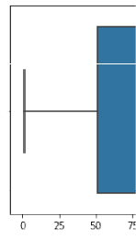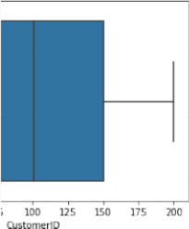

sns.boxplot(df['Gender'])

/usr/local/lib/python3.7/dist-packages/seaborn/_decorators.py:43: FutureWarnin g: Pass the following variable as a keyword arg: x. From version 0.12, the only valid positional argument will be `data`, and passing other arguments without a n explicit keyword will result in an error or misinterpretation.

FutureWarning

<matplotlib.axes._subplots.AxesSubplot at 0x7fdb8ebea250>

Out[ ]:

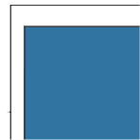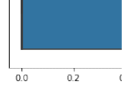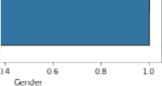

|  |  |
| --- | --- |
| In [ ]: |  |
| sns.boxplot(df['Age']) | |

/usr/local/lib/python3.7/dist-packages/seaborn/_decorators.py:43: FutureWarnin g: Pass the following variable as a keyword arg: x. From version 0.12, the only valid positional argument will be `data`, and passing other arguments without a n explicit keyword will result in an error or misinterpretation.

FutureWarning

<matplotlib.axes._subplots.AxesSubplot at 0x7fdb93b3ee50> Out[]:

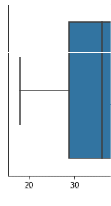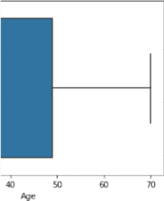

I n

[ ]: sns.boxplot(df['Annual Income (k$)'])

/usr/local/lib/python3.7/dist-packages/seaborn/_decorators.py:43: FutureWarnin g: Pass the following variable as a keyword arg: x. From version 0.12, the only valid positional argument will be `data`, and passing other arguments without a n explicit keyword will result in an error or misinterpretation.

FutureWarning

<matplotlib.axes._subplots.AxesSubplot at 0x7fdb8eb28450> Out[]:

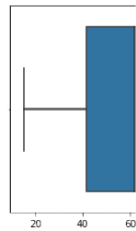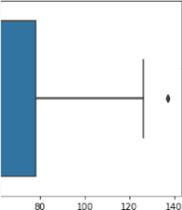

|  |
| --- |
| df['Annual Income (k$)'] = np.where(df['Annual Income (k$)'] > 132.750, 60.55, |

In [ ]:

In [ ]: sns.boxplot(df['AnnualIncome (k$)'])

/usr/local/lib/python3.7/dist-packages/seaborn/_decorators.py:43: FutureWarnin g: Pass the following variable as a keyword arg: x. From version 0.12, the only valid positional argument will be `data`, and passing other arguments without a n explicit keyword will result in an error or misinterpretation.

FutureWarning

<matplotlib.axes._subplots.AxesSubplot at 0x7fdb8eb18e90> Out[ ]:

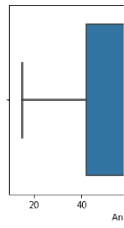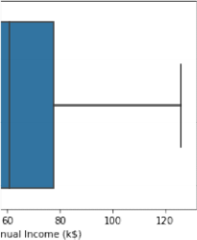

In [ ]: df['AnnualIncome (k$)'].max()

126.0 Out[]:

In [ ]:

sns.boxplot(df['Spending Score (1-100)'])

/usr/local/lib/python3.7/dist-packages/seaborn/_decorators.py:43: FutureWarnin g: Pass the following variable as a keyword arg: x. From version 0.12, the only valid positional argument will be `data`, and passing other arguments without a n explicit keyword will result in an error or misinterpretation.

FutureWarning

<matplotlib.axes._subplots.AxesSubplot at 0x7fdb8ea8fc10> Out[ ]:

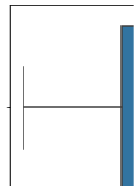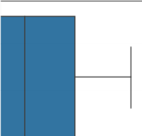

# Scaling the data

|  |  |  |  |
| --- | --- | --- | --- |
| from sklearn.preprocessing import  StandardScaler().fit_transform(df) ss | StandardScaler | ss | = |

In [ ]:

array([[-1.7234121 , 1.12815215, -1.42456879, -1.78843062, -0.43480148], Out[ ]:

[-1.70609137, 1.12815215, -1.28103541, -1.78843062, 1.19570407], [-1.68877065, -

0.88640526, -1.3528021 , -1.74850629, -1.71591298], [-1.67144992, -0.88640526, 1.13750203,-1.74850629,1.04041783],

[-1.6541292 , -0.88640526, -0.56336851, -1.70858195, -0.39597992], [-1.63680847, -

0.88640526, -1.20926872, -1.70858195, 1.00159627], [-1.61948775, -0.88640526, -

0.27630176, -1.66865761, -1.71591298], [-1.60216702, -0.88640526, -1.13750203, -

1.66865761,1.70038436],

[-1.5848463 , 1.12815215, 1.80493225, -1.62873328,-1.83237767], [-1.56752558, -0.88640526, -0.6351352,

-1.62873328,0.84631002],

[-1.55020485, 1.12815215,2.02023231, -1.62873328, -1.4053405 ],

[-1.53288413, -0.88640526, -0.27630176,-1.62873328, 1.89449216],

[-1.5155634 , -0.88640526, 1.37433211, -1.58880894, -1.36651894], [-1.49824268, -

0.88640526, -1.06573534, -1.58880894, 1.04041783], [-1.48092195, 1.12815215, -

0.13276838, -1.58880894, -1.44416206], [-1.46360123, 1.12815215, -1.20926872, -

1.58880894,1.11806095],

[-1.4462805 , -0.88640526, -0.27630176, -1.5488846 , -0.59008772], [-1.42895978,

1.12815215,-1.3528021, -1.5488846, 0.61338066],[-1.41163905,1.12815215,0.94373197,

-1.46903593, -0.82301709], [-1.39431833, -0.88640526, -0.27630176 , -1.46903593,

1.8556706],

[-1.3769976 , 1.12815215, -0.27630176, -1.42911159, -0.59008772], [-1.35967688,

1.12815215, -0.99396865, -1.42911159, 0.88513158], [-1.34235616, -0.88640526,

0.51313183, -1.38918726, -1.75473454], [-1.32503543, 1.12815215, -0.56336851, -

1.38918726,0.88513158],

[-1.30771471, -0.88640526, 1.08726535, -1.26941425,-1.4053405], [-1.29039398,1.12815215,-0.70690189, -1.26941425, 1.23452563], [-1.27307326, -0.88640526, 0.44136514, -1.26941425,-0.7065524],

[-1.25575253, 1.12815215, -0.27630176, -1.26941425, 0.41927286], [-1.23843181, -

0.88640526, 0.08253169, -1.22948991, -0.74537397], [-1.22111108, -0.88640526, -

1.13750203,-1.22948991,1.42863343],

[-1.20379036, 1.12815215,1.51786549, -1.18956557, -1.7935561 ],

[-1.18646963, -0.88640526, -1.28103541, -1.18956557, 0.88513158], [-1.16914891,

1.12815215,1.01549866,-1.06979256,-1.7935561 ],

[-1.15182818, 1.12815215, -1.49633548, -1.06979256, 1.62274124], [-1.13450746, 0.88640526, 0.7284319 , -1.06979256, -1.4053405],

[-1.11718674, -0.88640526, -1.28103541, -1.06979256, 1.19570407], [-1.09986601, -

0.88640526, 0.22606507, -1.02986823, -1.28887582], [-1.08254529, -0.88640526, -

0.6351352 , -1.02986823, 0.88513158], [-1.06522456, -0.88640526, -0.20453507, 0.91009522, -0.93948177], [-1.04790384, -0.88640526, -1.3528021 , -0.91009522,

0.96277471], [-1.03058311, -0.88640526, 1.87669894, -0.87017088, -0.59008772], [1.01326239, 1.12815215, -1.06573534, -0.87017088, 1.62274124], [-0.99594166,

1.12815215, 0.65666521, -0.83024654, -0.55126616], [-0.97862094, -0.88640526, -

0.56336851, -0.83024654, 0.41927286], [-0.96130021, -0.88640526, 0.7284319 , -

0.83024654, -0.86183865],

[-0.94397949, -0.88640526, -1.06573534, -0.83024654, 0.5745591],

|  |  |  |
| --- | --- | --- |
| [-0.92665877, -0.88640526, 0.80019859, -0.79032221, 0.18634349],  0.88640526, -0.85043527, -0.79032221, -0.12422899],  [-0.89201732, -0.88640526, -0.70690189, -0.79032221, -0.3183368],  [-0.87469659, -0.88640526, -0.56336851, -0.79032221, -0.3183368],  [-0.85737587, -0.88640526, 0.7284319, -0.71047353,0.06987881], | [-0.90933804, | - |
| [-0.84005514, 1.12815215, -0.41983513, -0.71047353, 0.38045129],  0.88640526, -0.56336851, -0.6705492 , 0.14752193],  [-0.80541369, 1.12815215, 1.4460988, -0.6705492 ,0.38045129],  [-0.78809297, -0.88640526, 0.80019859, -0.6705492 , -0.20187212], | [-0.82273442, | - |
| [-0.77077224, 1.12815215, 0.58489852, -0.6705492 , -0.35715836], | [-0.75345152, | - |

0.88640526,0.87196528,-0.63062486, -0.00776431],

[-0.73613079, 1.12815215, 2.16376569, -0.63062486, -0.16305055], [-0.71881007, -

0.88640526, -0.85043527, -0.55077619, 0.03105725], [-0.70148935, 1.12815215,

1.01549866, -0.55077619, -0.16305055], [-0.68416862, 1.12815215, 2.23553238, -

0.55077619,0.22516505],

[-0.6668479 , 1.12815215,-1.42456879,-0.55077619, 0.18634349],

[-0.64952717, -0.88640526,2.02023231,-0.51085185,0.06987881],

[-0.63220645, -0.88640526,1.08726535,-0.51085185,0.34162973],

[-0.61488572,1.12815215,1.73316556, -0.47092751,0.03105725],

[-0.597565 , 1.12815215,-1.49633548,-0.47092751, 0.34162973],

[-0.58024427, -0.88640526,0.29783176,-0.47092751, -0.00776431],

[-0.56292355, -0.88640526, 2.091999 , -0.47092751, -0.08540743], [-0.54560282,

1.12815215, -1.42456879, -0.47092751, 0.34162973], [-0.5282821 , -0.88640526, -

0.49160182, -0.47092751, -0.12422899], [-0.51096138, 1.12815215, 2.23553238, 0.43100318,0.18634349],[-0.49364065,-0.88640526,0.58489852,-0.43100318,-0.3183368

],

[-0.47631993, -0.88640526, 1.51786549, -0.39107884, -0.04658587], [-0.4589992 , 0.88640526,1.51786549,-0.39107884,0.22516505],[-0.44167848,1.12815215,1.4460988, -0.23138149,-0.12422899],

[-0.42435775, 1.12815215,-0.92220196, -0.23138149, 0.14752193],

[-0.40703703, -0.88640526, 0.44136514, -0.23138149, 0.10870037], [-0.3897163 ,

1.12815215, 0.08253169, -0.23138149, -0.08540743], [-0.37239558, -0.88640526, -

1.13750203,-0.23138149,0.06987881],

[-0.35507485, -0.88640526, 0.7284319, -0.23138149, -0.3183368],

[-0.33775413,1.12815215, 1.30256542, -0.23138149, 0.03105725],

[-0.3204334 , 1.12815215, -0.06100169, -0.23138149, 0.18634349],

[-0.30311268, 1.12815215,2.02023231, -0.23138149,-0.35715836],

[-0.28579196, -0.88640526, 0.51313183, -0.23138149, -0.24069368], [-0.26847123, 0.88640526, -1.28103541, -0.23138149, 0.26398661], [-0.25115051, 1.12815215,

0.65666521,-0.23138149,-0.16305055],

[-0.23382978, -0.88640526, 1.15903204, -0.11160848, 0.30280817],

[-0.21650906, -0.88640526, -1.20926872,-0.11160848, 0.18634349],

[-0.19918833, -0.88640526, -0.34806844, -0.07168415, 0.38045129], [-0.18186761, 0.88640526, 0.80019859, -0.07168415, -0.16305055], [-0.16454688, -0.88640526, 2.091999 , -0.03175981,0.18634349],

[-0.14722616,1.12815215,-1.49633548, -0.03175981, -0.35715836],

|  |  |  |
| --- | --- | --- |
| [-0.12990543, 1.12815215,0.65666521, 0.00816453, -0.04658587],  [-0.11258471, -0.88640526, 0.08253169,0.00816453, -0.39597992],  [-0.09526399, -0.88640526,-0.49160182,0.00816453, -0.3183368 ],  [-0.07794326, 1.12815215,-1.06573534,0.00816453, 0.06987881],  [-0.06062254, -0.88640526, 0.58489852,0.00816453, -0.12422899], |  | |
| [-0.04330181, -0.88640526, -0.85043527, 0.00816453, -0.00776431],  1.12815215, 0.65666521, 0.04808886,-0.3183368], | [-0.02598109, | |
| [-0.00866036, 1.12815215, -1.3528021 , 0.04808886, -0.04658587], [  0.88640526, -1.13750203,0.0880132 , -0.35715836], | 0.00866036, - | |
| [ 0.02598109, -0.88640526, 0.7284319 , 0.0880132 , -0.08540743],  1.12815215, 2.02023231, 0.0880132, 0.34162973],  [ 0.06062254, 1.12815215, -0.92220196, 0.0880132 , 0.18634349],  [ 0.07794326, 1.12815215, 0.7284319, 0.0880132, 0.22516505],  [ 0.09526399, -0.88640526,-1.28103541, 0.0880132, -0.3183368 ],  [ 0.11258471, -0.88640526,1.94846562,0.12793754, -0.00776431],  [ 0.12990543, 1.12815215, 1.08726535,0.12793754, -0.16305055],  [ 0.14722616, 1.12815215, 2.091999, 0.12793754, -0.27951524], | [ | 0.04330181, |
| [ 0.16454688, 1.12815215, 1.94846562, 0.12793754, -0.08540743],  1.12815215,1.87669894,0.12793754,0.06987881],  [ 0.19918833, -0.88640526, -1.42456879, 0.12793754,0.14752193],  [ 0.21650906, -0.88640526,-0.06100169,0.16786187, -0.3183368 ],  [ 0.23382978, 1.12815215, -1.42456879, 0.16786187, -0.16305055],  [ 0.25115051,-0.88640526,-1.49633548, 0.20778621,-0.08540743], [ 0.26847123,-0.88640526,-1.42456879, 0.20778621,-0.00776431], | [ | 0.18186761, |
| [ 0.28579196, -0.88640526, 1.73316556, 0.20778621, -0.27951524], [ 0.30311268, - | | |

0.88640526, 0.7284319, 0.20778621, 0.34162973], [ 0.3204334 , -0.88640526, 0.87196528,

0.28763488,-0.27951524],

[ 0.33775413, -0.88640526,0.80019859, 0.28763488, 0.26398661],

[ 0.35507485, 1.12815215, -0.85043527, 0.28763488, 0.22516505], [ 0.37239558, -

0.88640526, -0.06100169,0.28763488, -0.39597992],

[ 0.3897163, -0.88640526,0.08253169, 0.36748356, 0.30280817],

[ 0.40703703, 1.12815215, 0.010765, 0.36748356, 1.58391968],[ 0.42435775, -0.88640526, -1.13750203, 0.40740789, -0.82301709], [ 0.44167848, -0.88640526, -0.56336851,

0.40740789,1.04041783],[ 0.4589992, 1.12815215,0.29783176,0.44733223,-0.59008772],

[ 0.47631993, 1.12815215, 0.08253169, 0.44733223, 1.73920592], [ 0.49364065,

1.12815215,1.4460988, 0.44733223,-1.52180518],[0.51096138,1.12815215,-0.06100169,

0.44733223,0.96277471],

[ 0.5282821 , 1.12815215, 0.58489852, 0.44733223, -1.5994483 ],

[ 0.54560282,1.12815215,0.010765, 0.44733223, 0.96277471], [ 0.56292355, -0.88640526, -0.99396865, 0.48725657, -0.62890928], [ 0.58024427, -0.88640526, -0.56336851,

0.48725657, 0.80748846],[ 0.597565 , 1.12815215, -1.3528021 , 0.5271809 , -1.75473454], [ 0.61488572, -0.88640526, -0.70690189, 0.5271809 , 1.46745499], [ 0.63220645, -

0.88640526,0.36959845,0.5271809 ,-1.67709142],[0.64952717,1.12815215,-0.49160182,

[0.50.68416862271809, 0.8,85-0.8864052613158],[0.66, 68-0.27630176479, 1.1281, 50.56710524215,-1.42456, 0.84631002]879,0.56710,524[ ,0.70148935-1.56062674, ], -

0.88640526, 1.30256542, 0.60702958, -1.75473454],

[ 0.71881007, 1.12815215, -0.49160182,0.60702958, 1.6615628],

[ 0.73613079, -0.88640526, -0.77866858, 0.64695391, -0.39597992], [ 0.75345152, -

0.88640526, -0.49160182, 0.64695391, 1.42863343], [ 0.77077224, 1.12815215, 0.99396865, 0.68687825, -1.48298362], [ 0.78809297, 1.12815215, -0.77866858,

0.68687825, 1.81684904], [ 0.80541369, 1.12815215, 0.65666521, 0.68687825, -

0.55126616], [ 0.82273442, -0.88640526, -0.49160182, 0.68687825, 0.92395314], [

0.84005514, -0.88640526, -0.34806844, 0.72680259, -1.09476801], [ 0.85737587,

1.12815215,-0.34806844,0.72680259,1.54509812],[ 0.87469659,1.12815215,0.29783176,

0.72680259, -1.28887582],[ 0.89201732, 1.12815215, 0.010765, 0.72680259,1.46745499],

[ 0.90933804, -0.88640526, 0.36959845, 0.72680259, -1.17241113], [ 0.92665877, 0.88640526, -0.06100169, 0.72680259, 1.00159627], [ 0.94397949, -0.88640526,

0.58489852, 0.72680259, -1.32769738], [ 0.96130021, -0.88640526, -0.85043527,

0.72680259, 1.50627656], [ 0.97862094, 1.12815215, -0.13276838, 0.72680259, 1.91002079], [ 0.99594166, -0.88640526, -0.6351352 , 0.72680259, 1.07923939], [

1.01326239, 1.12815215, -0.34806844, 0.72680259, -1.91002079], [ 1.03058311, -

0.88640526,-0.6351352, 0.72680259,0.88513158],[1.04790384,-0.88640526,1.23079873,

0.76672692, -0.59008772], [ 1.06522456, -0.88640526, -0.70690189, 0.76672692,

1.27334719], [1.08254529,1.12815215, -1.42456879, 0.8465756 , -1.75473454],

[ 1.09986601, -0.88640526,-0.56336851, 0.8465756 , 1.6615628],

[ 1.11718674, 1.12815215, 0.80019859, 1.00627294, -0.93948177], [ 1.13450746, -

0.88640526,-0.20453507,1.00627294,0.96277471],[ 1.15182818,1.12815215,0.22606507,

1.04619728, -1.17241113], [ 1.16914891, -0.88640526, -0.41983513, 1.04619728, 1.73920592],

[ 1.18646963, -0.88640526, -0.20453507, 1.08612162, -0.90066021], [ 1.20379036,

1.12815215,-0.49160182,1.08612162,0.49691598],[ 1.22111108,1.12815215,0.08253169,

1.08612162, -1.44416206], [ 1.23843181, 1.12815215, -0.77866858, 1.08612162,

1. 96277471], [ 1.25575253, 1.12815215, -0.20453507, 1.08612162, -1.56062674], [

1.27307326, 1.12815215, -0.20453507, 1.08612162, 1.62274124], [ 1.29039398, 0.88640526,0.94373197,1.12604595,-1.44416206],[ 1.30771471,-0.88640526,-0.6351352 , 1.12604595, 1.38981187], [ 1.32503543, 1.12815215, 1.37433211, 1.12604595, -

1. 36651894], [ 1.34235616, 1.12815215, -0.85043527, 1.12604595, 0.72984534], [

1.35967688, 1.12815215,1.4460988 , 1.32566764, -1.4053405 ],

[ 1.3769976, 1.12815215,-0.27630176, 1.32566764, 1.54509812],

[ 1.39431833, -0.88640526,-0.13276838, 1.48536498,-0.7065524 ],

[ 1.41163905, -0.88640526, -0.49160182, 1.48536498, 1.38981187], [ 1.42895978,

1.12815215, 0.51313183, 1.52528932, -1.36651894], [ 1.4462805 , -0.88640526, 0.70690189,1.52528932,1.46745499],[ 1.46360123,-0.88640526,0.15429838,1.56521366,

-0.43480148],[ 1.48092195,1.12815215, -0.6351352 , 1.56521366, 1.81684904],

[ 1.49824268, -0.88640526,1.08726535, 1.64506233, -1.01712489],

[ 1.5155634 , 1.12815215, -0.77866858, 1.64506233, 0.69102378], [ 1.53288413, 0.88640526,0.15429838,1.724911, -1.28887582],[ 1.55020485,-0.88640526,-0.20453507,

1.724911, 1.35099031],

[ 1.56752558, -0.88640526,-0.34806844, 1.724911, -1.05594645],

[ 1.5848463, -0.88640526,-0.49160182,1.724911 , 0.72984534], [ 1.60216702, 1.12815215,

-0.41983513, 2.12415437, -1.63826986], [ 1.61948775, -0.88640526, -0.06100169,

2.12415437, 1.58391968], [ 1.63680847, -0.88640526, 0.58489852, 2.40362473, -

1.32769738], [ 1.6541292 , -0.88640526, -0.27630176, 2.40362473, 1.11806095], [ 1.67144992, -0.88640526, 0.44136514, 2.64317075, -0.86183865], [ 1.68877065,

1.12815215, -0.49160182,2.64317075, 0.92395314],

[ 1.70609137, 1.12815215, -0.49160182,0.03012291, -1.25005425], [ 1.7234121 , 1.12815215, -0.6351352 , 0.03012291, 1.27334719]])

# ClusteringAlgorithm

|  |
| --- |
| from sklearn.cluster import KMeans TWSS = [] k = list(range(2,9))  for i in k:  kmeans = KMeans(n_clusters = i , init = 'k-means++') kmeans.fit(df) TWSS.append(kmeans.inertia_) |

In [ ]:

In [ ]:

TWSS

[381507.64738523855, Out[]:

268062.55433747417,

191550.08627670942, 153530.68956249507,

119166.15727643928,

101321.0166427429,

85744.90139221892]

In [ ]:



